SESSION 16 ASSIGNEMNT 1

**Problem Statement:** Given a list of numbers - List[Int] (1, 2, 3, 4, 5, 6, 7, 8, 9, 10)

* Find the sum of all numbers
* Find the total elements in the list
* Calculate the average of the numbers in the list
* Find the sum of all the even numbers in the list
* Find the total number of elements in the list divisible by both 5 and 3

**Solution:**

Spark Code:

import org.apache.spark.sql.SparkSession

object Assignment_17_1 extends App {

val spark = SparkSession.builder()

.master("local")

.appName("example")

.config("spark.sql.warehouse.dir", "file:///C:")

.getOrCreate()

val sc = spark.sparkContext

val list_1 = sc.parallelize(1 to 10)

//sum of list

println("Sum of even numbers = " + list_1.sum())

//length of list

println("Total numbers = " + list_1.count())

//Average

println("Average of numbers = " + (list_1.sum()/list_1.count()))

//filter out even nos

val even = list_1.filter(x => x%2==0)

println("Sum of even numbers = " + even.sum())

//filter out nos divisible by 3 and 5

val div = list_1.filter(x => (x%3==0 && x%5==0))

println("Numbers divisible by 3 and 5 = " + div.count())

}

**Output:**

* Find the sum of all numbers

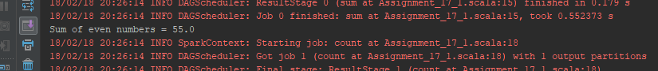

* Find the total elements in the list

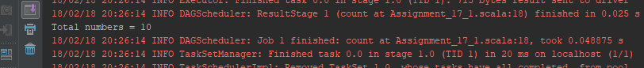

* Calculate the average of the numbers in the list

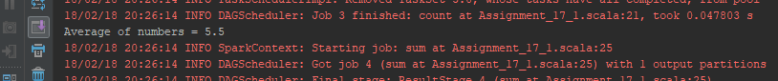

* Find the sum of all the even numbers in the list

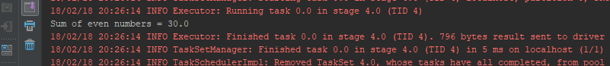

* Find the total number of elements in the list divisible by both 5 and 3

